**Practical - 1**

**Aim :**

Addition, Subtraction, Multiplication, Division of:

1. two 8-bit numbers
2. two 16-bit numbers

Note: get the data form registers, result should be available in register

**Description of instructions used :**

MOV: Transfer data from one register or memory location to another register or memory location.

ADD: Adds immediate data or memory location or register to memory location or register. Source and destination for ADD can’t be memory location.

SUB: Subtracts immediate data or memory location or register to memory location or register. Source and destination for SUB can’t be memory location.

MUL: Unsigned multiplication of byte or word from register or memory location with AX register.

DIV: Unsigned division of word or double from register or memory location with AX register.

8-bit

**Code : Addition**

mov al,30h

mov bl,45h

add al,bl

**Output :**

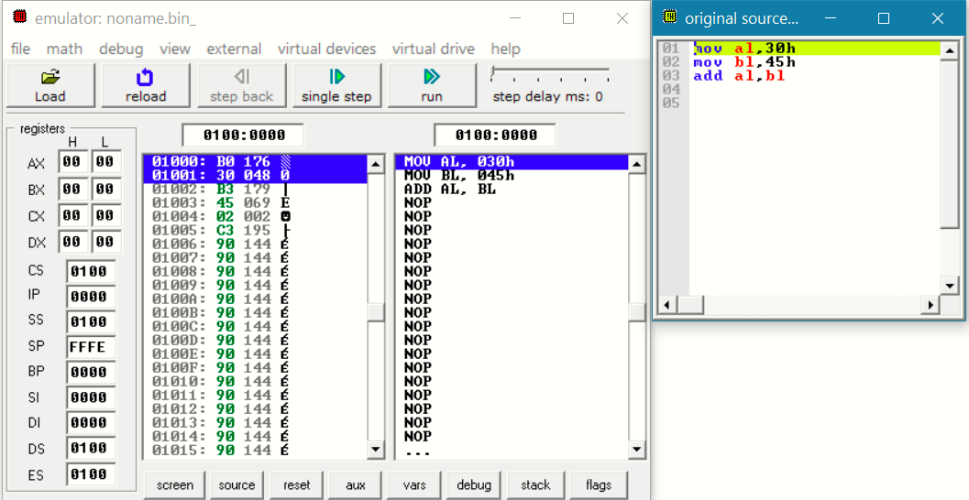

**Code : Subtraction**

mov al,60h

mov bl,45h

sub al,bl

**Output:**

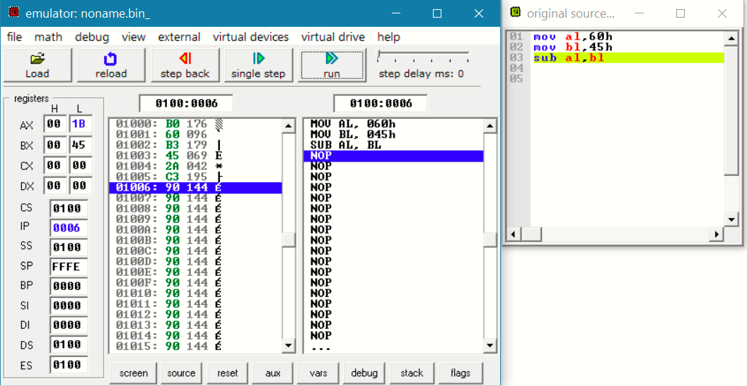

**Code : Multiplication**

mov al,12h

mov bl,2h

mul bl

**Output :**

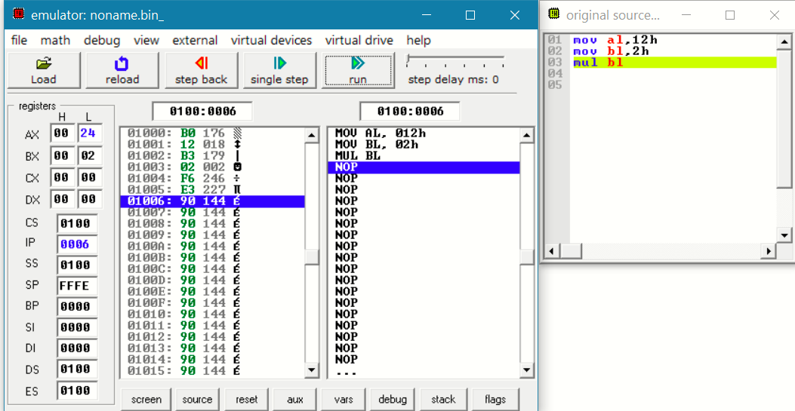

**Code : Division**

mov al,22h

mov bl,2h

div bl

**Output :**

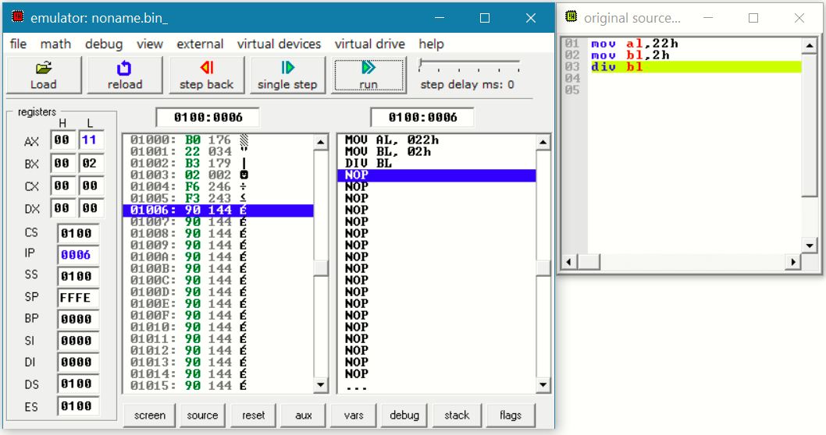

16-bit

**Code : Addition**

mov ax,3000h

mov bx,4500h

add ax,bx

**Output :**

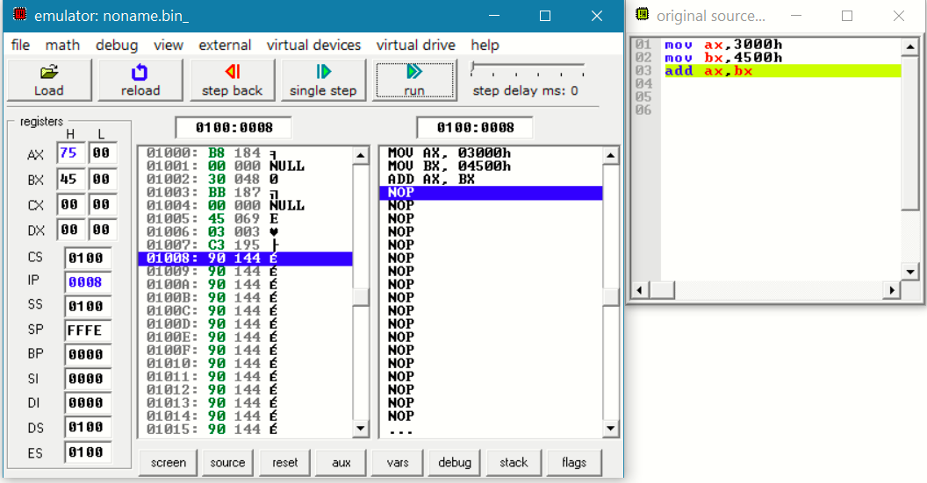

**Code : Subtraction**

mov ax,6000h

mov bx,4500h

sub ax,bx

**Output:**

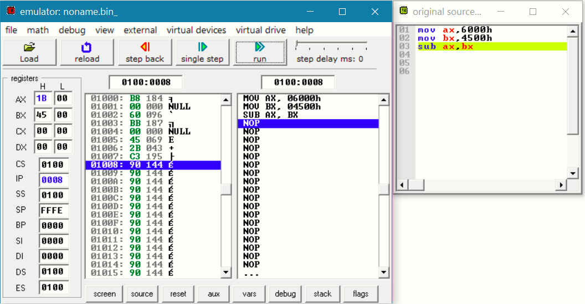

**Code : Multiplication**

mov ax,2222h

mov bx,1111h

mul bx

**Output :**

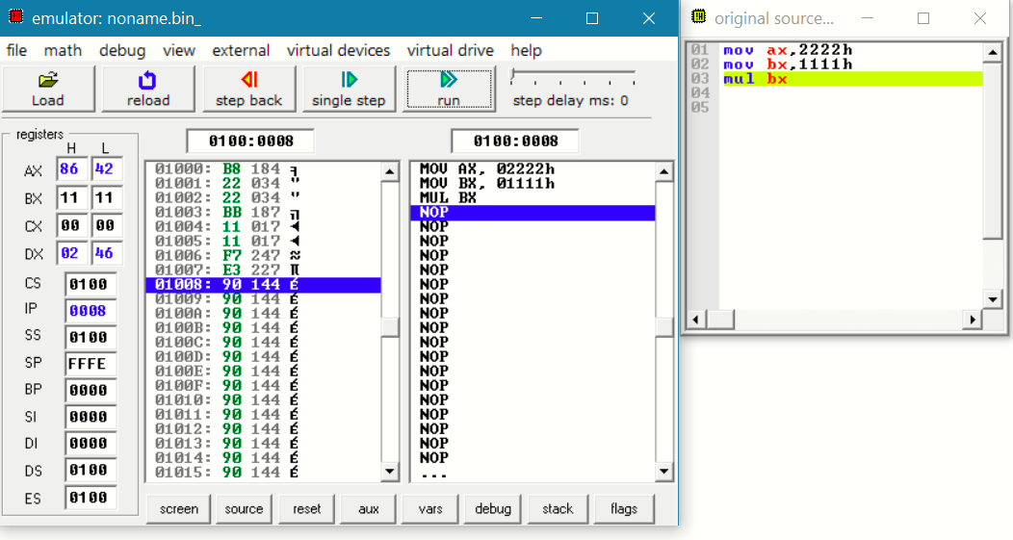

**Code : Division**

mov ax,2222h

mov bx,1111h

div bx

**Output :**

